Naked Bass Wedding Booking Form
Congratulations on your special day!!! We are delighted and extremely proud to have been chosen as your wedding band! We are very thorough with requirements and would really appreciate it if you could take some time to fill out our booking form. If certain boxes don’t apply please feel free to leave them blank, upon receipt of your form, please email to - mattsbands@hotmail.com, and we will follow up with a phone call to confirm details. We aim to provide a first class service and hope to help make your day as easy and enjoyable as possible, thank you for your invitation.
Personal Details:
Names: | Venue & contact no:
Contact Number : | Date of Event:
Email Address: | Time Guests Arrive:
Time Arranged for NB to Setup: | Time Band Commences:

Requirements: (either tick or delete as appropriate)

Full Live Band £650 □ | PA Hire for speeches (afternoon) £100□
Acoustic Duo £350□ | PA hire and playlist (evening) £100 □
External Services £120 + □  i.e. Face painter – this price may vary depending on service required | Additional Equipment Hire £50 per item □  Bubble/Smoke Machine/lighting

Bridesmaids Colours: (If requested we can wear matching ties)

First Dance:

Song Requests (Band Set): (depending on notice, maximum of two additional requests)
Song Requests (PA Evening Playlist Set):

Set List (Please either tick songs required or delete songs not requested to give us an idea of your music tastes)

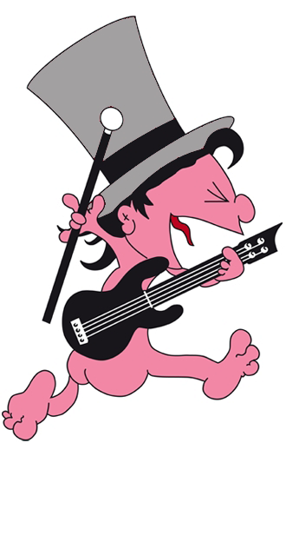

Congratulations and many thanks - Naked Bass!
T:07709137538 E:mattsbands@hotmail.co.uk
 WE WILL ROCK YOU – QUEEN |  SWEET CHILD OF MINE – GUNS AND ROSES
 MESSAGE IN A BOTTLE – THE POLICE |  WORRIED ABOUT RAY - THE HOOSIERS
 YOU AND ME SONG – THE WANNADIES |  SONG 2 – BLUR
 MUSTANG SALLY – THE COMMITMENTS |  CRAZY LITTLE THING CALLED LOVE – QUEEN
 SUMMER OF 69 - BRYAN ADAMS |  WONDERWALL – OASIS
 BASKET CASE – GREENDAY |  PLACE YOUR HANDS -REEF
 I'M A BELIEVER – THE MONKEES |  I CANT READ YOU – DANIEL BEDDINGFIELD
 SEX ON FIRE - KINGS OF LEON |  ARMY OF LOVERS – LEE RYAN
 500 MILES – THE PROCLAIMERS |  BILLY JEAN – MICHAEL JACKSON
 ALRIGHT NOW – FREE |  BLACK IN BLACK – AC/DC
 KEEP ON ROCKING IN THE FREE WORLD – NEIL YOUNG |  I BELIEVE IN A THING CALLED LOVE – THE DARKNESS
 STUCK IN THE MIDDLE – STEELERS WHEEL |  JENNY DONT BE HASTY – PAULO NUTINI
 SMELLS LIKE TEEN SPIRIT – NIRVANA |  AMERICA – RAZORLIGHT
 ENTER SAND MAN – METALLICA |  MR BRIGHTSIDE – THE KILLERS
 ROXANNE – THE POLICE |  MONKEY WRENCH – FOO FIGHTERS
 DAY TRIPPER – THE BEATLES |  JUST THE WAY IM FEELING – FEEDER
 HOW YOU REMIND ME – NICKLEBACK |  KNOCKING ON HEAVENS DOOR – BOB DYLAN
 WONDERFUL TONIGHT – ERIC CLAPTON |  MONEY FOR NOTHING – DIRE STRAITS
 NAÏVE – THE KOOKS |  LIVING ON A PRAYER – BON JOVI
 MY HERO – THE FOO FIGHTERS |  BEAT IT - MICHAEL JACKSON
 TAKE ON ME – A-HA |  FORGET YOU - CEELO GREEN
 SOMEONE LIKE YOU – ADELE |  USE SOMEBODY – KINGS OF LEON
 WITH OR WITHOUT YOU – U2 |  PLUG IN BABY – MUSE
 BLUES/ROCKMEDLEY:  JOHNY BE GOOD / TUTTIE FRUITI / BLUE SUEDE SHOES / GOOD GOOLLY / ROCK N ROLL |  LABAMBA  TWIST AND SHOUT / HEY BABY / *REGGAE* -TALLY MAN DRUMS / FOR WIPEOUT SOLO'S / LABAMBA

